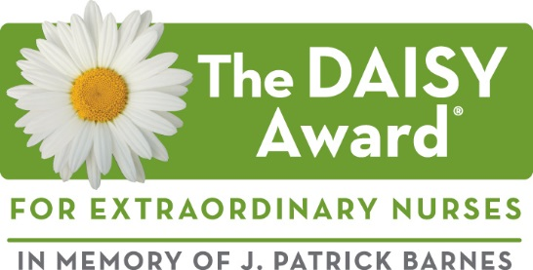

Click or tap here to enter text.

In the space below, please describe a specific situation or story that demonstrates how this nurse made a meaningful difference in your care. Please continue on the next page and add additional pages as needed.

I would like to thank my nurse (name): Click or tap here to enter text.
Unit /Department: Click or tap here to enter text.
The DAISY (Diseases Attacking the Immune SYstem) Award is an international recognition program that honors and celebrates the skillful, compassionate care nurses provide every day. The DAISY Foundation was established by the family of J. Patrick Barnes after he died from complications of the auto-immune disease ITP in 1999. During his hospitalization, they deeply appreciated the care and compassion shown to Patrick and his entire family. When he died, they felt compelled to say “thank you” to nurses in a very public way. Please say thank you by sharing your story of how a nurse made a difference you will never forget!

Thank you for taking the time to nominate an extraordinary nurse for this award. Please tell us about yourself,
Want to Say Thank You to Your Nurse?
Share Your Story!

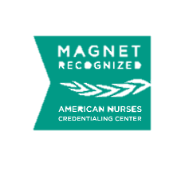
so that we may include you in the celebration of this award should the nurse you nominated is selected.

Your Name Click or tap here to enter text. Date of nomination Click or tap here to enter text.
Phone: Click or tap here to enter text. Email: Click or tap here to enter text.

I am (please check one):
☐ Patient ☐ Visitor ☐ RN ☐MD ☐Staff ☐Volunteer

Please submit your nomination form to:
Nauka Thakker RN, MSN, APN
Nursing Education - Morristown Medical Center
Interoffice Box 163
Email: Nauka.thakker@atlantichealth.org

© DAISY Foundation 2017
Continue your story in the space below
Click or tap here to enter text.

If you have any questions, please contact:
Nauka.Thakker@atlantichealth.org

